LearnHub

Your Center for Skill Enhancement

1. INTRODUCTION

1.1 Project Overview
LearnHub is a full-stack Online Learning Platform (OLP) designed to provide accessible, flexible, and interactive skill-based education through the internet. The platform supports multiple user roles—Students, Teachers, and Admins—enabling course creation, enrollment, learning progress tracking, certification, and administrative control. LearnHub aims to bridge the gap between learners and educators by offering a structured, scalable, and user-friendly digital learning environment.

1.2 Purpose
The primary purpose of LearnHub is to enable learners to acquire new skills at their own pace while providing educators with tools to create, manage, and monetize courses. The platform also supports institutions and administrators in monitoring learning activities and maintaining system integrity.

2. IDEATION PHASE

Problem Statement
Traditional learning systems often lack flexibility, accessibility, and personalization. Learners face challenges such as fixed schedules, limited course availability, and lack of continuous progress tracking. Educators also struggle with course management and reaching a wider audience.

Proposed Idea
LearnHub addresses these challenges by providing a centralized online learning platform where users can access courses anytime, interact with instructors, and earn certifications, while educators can efficiently manage and deliver content.
Team ID : LTVIP2026TMIDS24292
Team Size: 4
Team Leader: Akuri Afreen
Team member: Alajangi Keerthi
Team member: Katta Lakshmi Kameswara Rao
Team member: Suragani Ushakeerthi

Key Objectives
- Provide a user-friendly and responsive learning platform
- Enable self-paced and interactive learning
- Support paid and free courses with secure transactions
- Ensure scalability and efficient data managemen

3. REQUIREMENT ANALYSIS

3.1 Functional Requirements
- User registration and authentication
- Role-based access (Student, Teacher, Admin)
- Course creation, modification, and deletion
- Course enrollment and progress tracking
- Certification generation after course completion
- Secure payment system for paid courses

3.2 Non-Functional Requirements
- High availability and scalability
- Secure authentication and data protection
- Responsive UI across devices
- Fast response time and efficient API communication

3.3 Data Storage Design
The system uses two primary MongoDB collections:
Users Collection
- _id
- name
- email
- password
- type
Courses Collection
- _id
- userID (educator reference)
- C_educator
- C_categories
- C_title
- C_description
- sections
- C_price
- enrolled

4. TECHNICAL ARCHITECTURE
LearnHub follows a client-server architecture.

Frontend
- Built using React with Vite for fast development
- Uses Bootstrap and Material UI for responsive design
- Axios is used for RESTful API communication

Backend
- Developed using Express.js and Node.js
- Handles authentication, authorization, and business logic
- Uses JWT for secure user sessions

Database
- MongoDB for scalable NoSQL data storage
- Mongoose ODM for schema management and CRUD operations
This architecture ensures seamless communication, modular development, and efficient data handling.

5. APPLICATION FLOW

User Roles and Responsibilities
Student
- Register and log in
- Browse and enroll in courses
- Resume courses from last progress
- Complete courses and download certificates
- Purchase paid courses
Teacher
- Create and manage courses
- Add or remove course sections
- Delete courses if no students are enrolled
Admin
- Manage all users and courses
- Monitor platform activities
- Maintain data integrity and system performance

6. PROJECT PLANNING AND DEVELOPMENT

6.1 Project Setup
- Created separate frontend and backend directories
- Installed required dependencies for both environments

6.2 Backend Development
- Configured Express server and environment variables
- Implemented authentication middleware
- Integrated MongoDB using Mongoose

6.3 Frontend Development
- Built responsive UI components using React
- Implemented dashboards for Student, Teacher, and Admin
- Integrated APIs using Axios

7. IMPLEMENTATION AND EXECUTION
After development, the application was tested thoroughly to verify all functionalities. The system includes:
- Landing Page
- Registration and Login Pages
- Admin Dashboard
- Teacher Dashboard
- Student Dashboard
Each module was validated for correctness, usability, and performance.

8. ADVANTAGES AND LIMITATIONS

Advantages
- User-friendly and responsive interface
- Supports self-paced and interactive learning
- Scalable architecture
- Role-based access control

Limitations
- Requires stable internet connectivity
- Limited offline access

9. Results

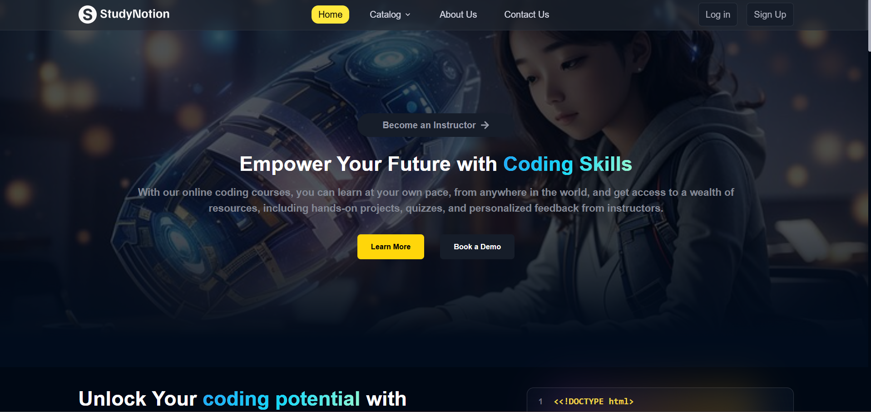

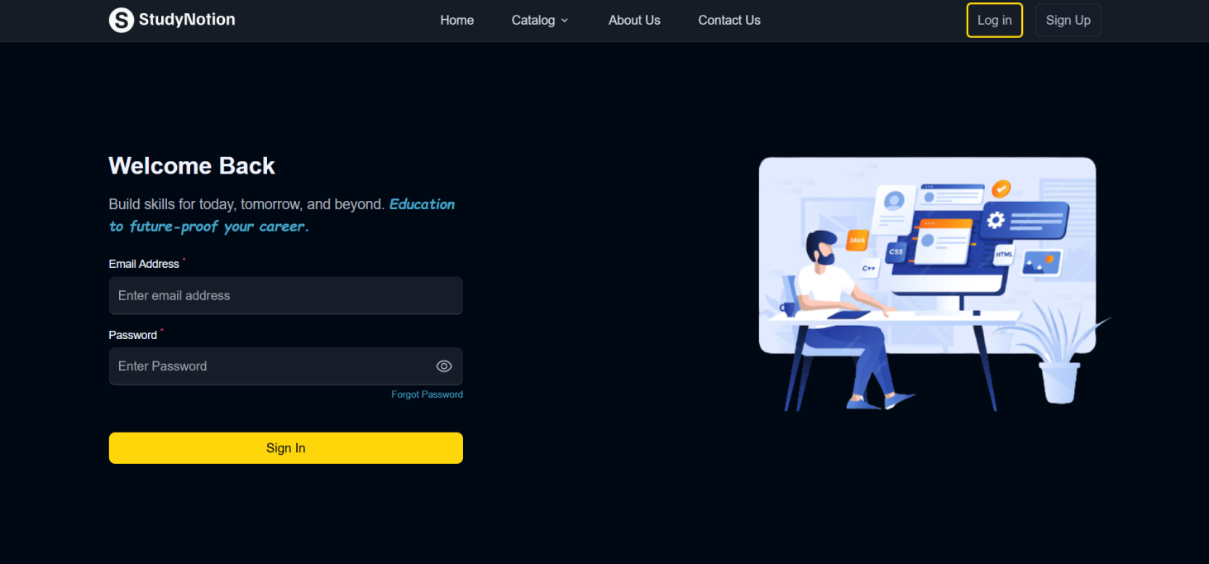



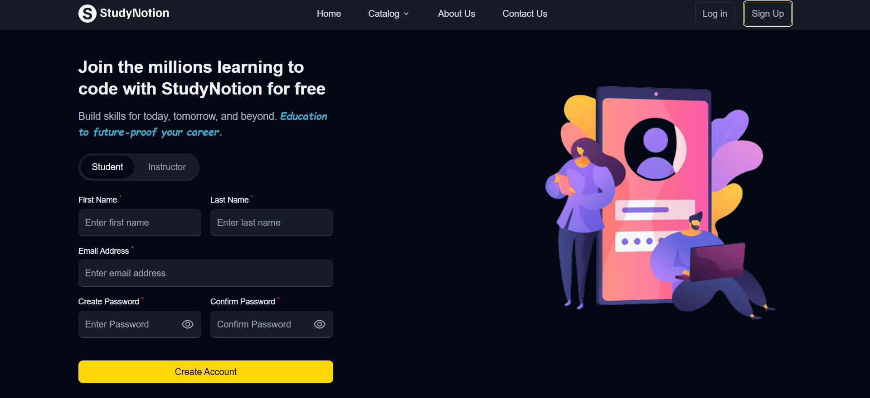

10. CONCLUSION
LearnHub successfully demonstrates the implementation of a modern Online Learning Platform using full-stack web technologies. The system provides an effective solution for digital education by integrating course management, learning progress tracking, and certification in a single platform.

11. FUTURE SCOPE
- Mobile application development
- AI-based course recommendations
- Live class integration
- Multilingual support

12. REFERENCES
- Node.js Documentation
- Express.js Documentation
- MongoDB Documentation
- React.js Documentation

13. APPENDIX

